**Name -Monika Gariya**

**Email-** [**monikagariya2023@gmail.com**](mailto:monikagariya2023@gmail.com)

**Data Engineering Batch 1**

**Date – 30-01-2024**

**Topic – How to Read and Write files using Python, Python Lambda Function**

**1)** List of Methods to Read a CSV File in Python

* **Read CSV file using csv. reader**
* **Read CSV file using. Readlines () function**
* **Read CSV file using Pandas**
* **Read CSV file using csv. DictReader**

1)Read CSV file using csv. Reader

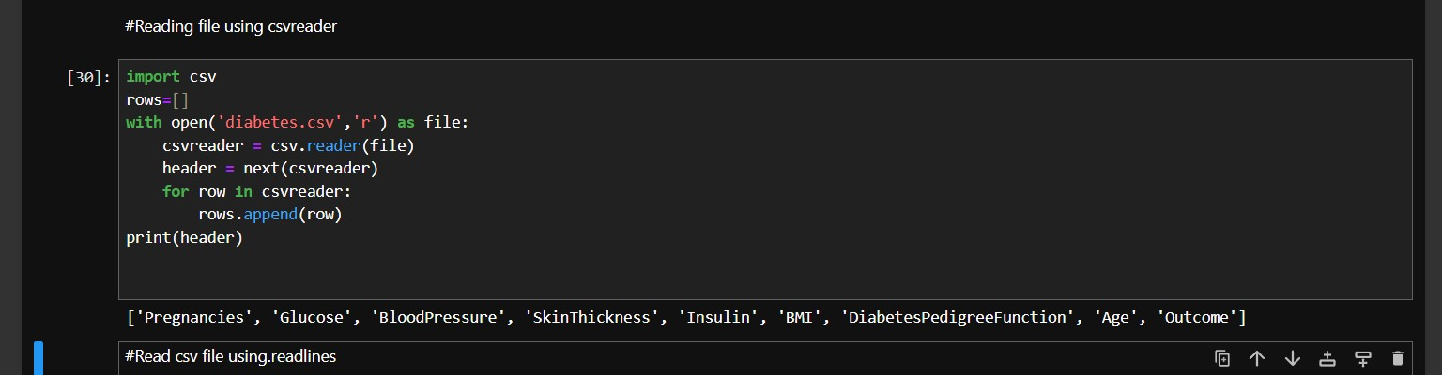

2) Read CSV file using. Readlines () function

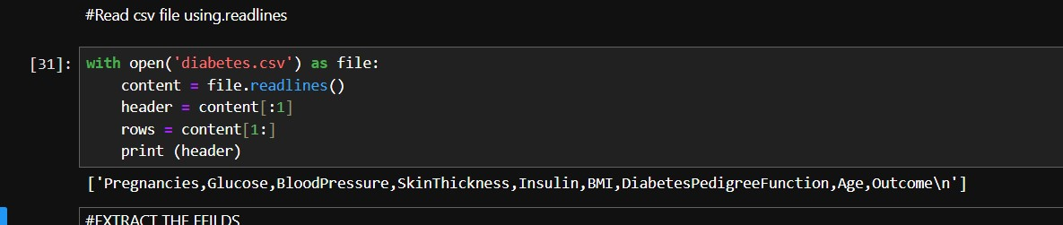

3) Read CSV file using Pandas

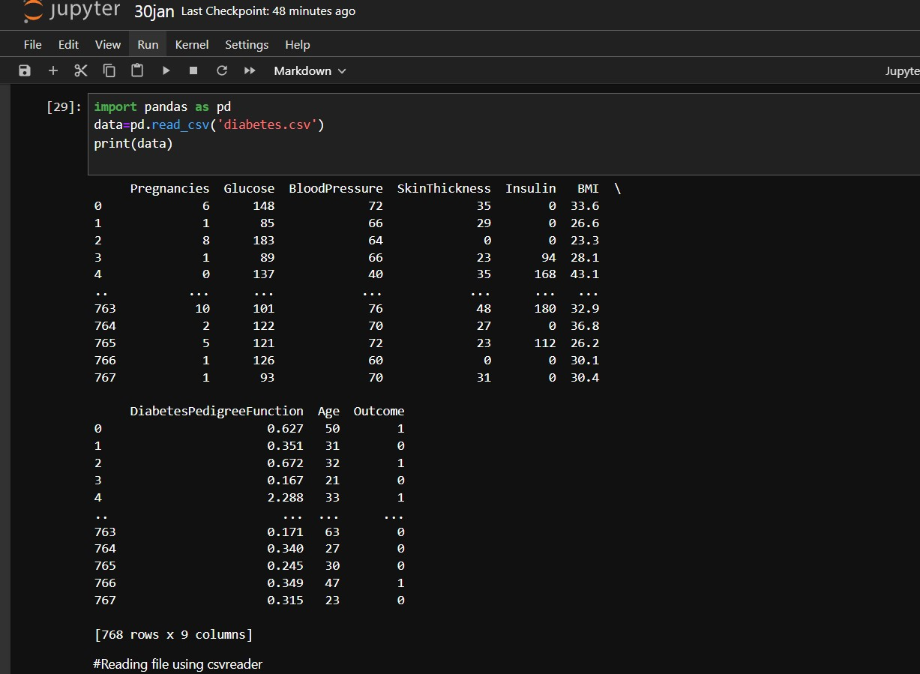

4) Read CSV file using csv. DictReader

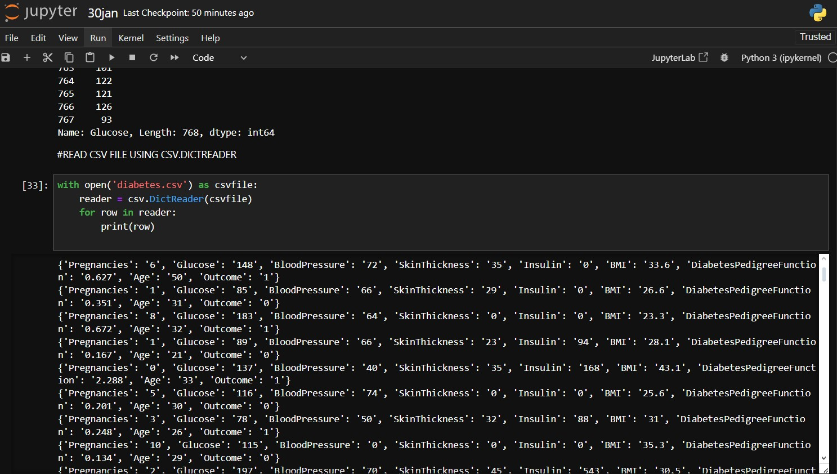

Q)Read File Line By Line

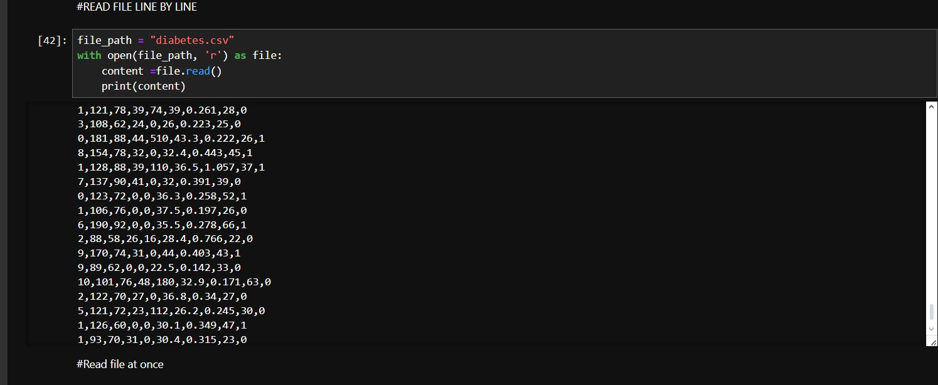

Q)Read file at once

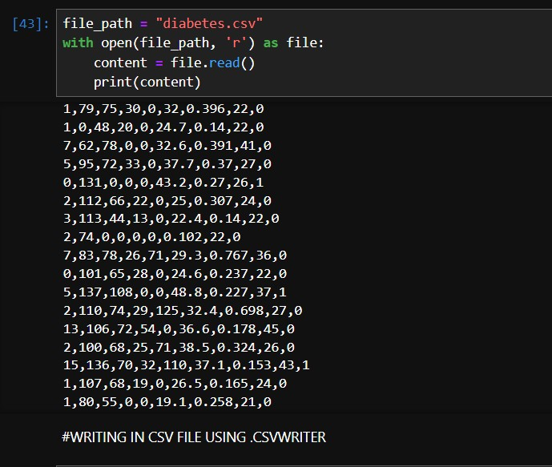

List of Methods to Write a CSV file in python

* **Write CSV file using csv.writer**
* **Write CSV file using writelines() function**
* **Write CSV file using Pandas**

1. Write CSV file using csv.writer

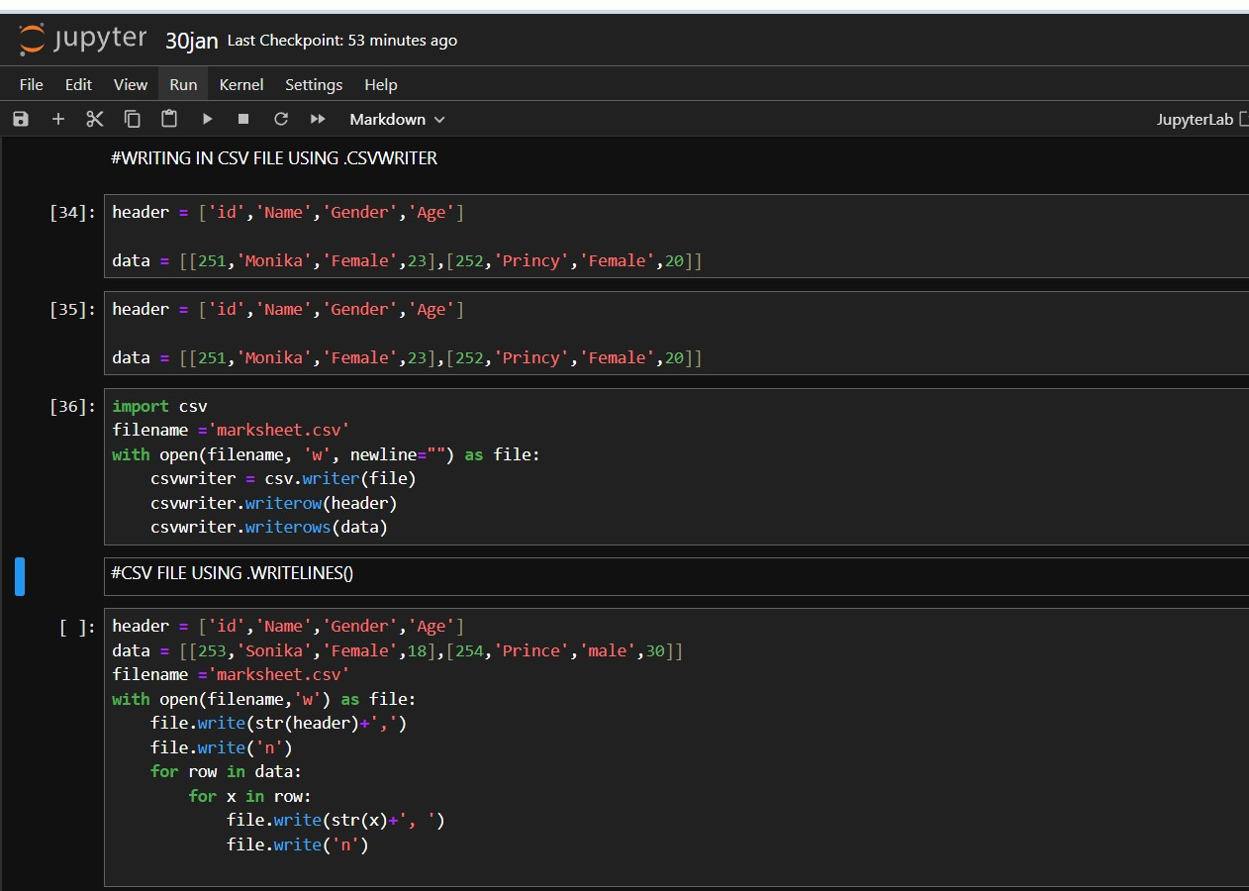

OUTPUT

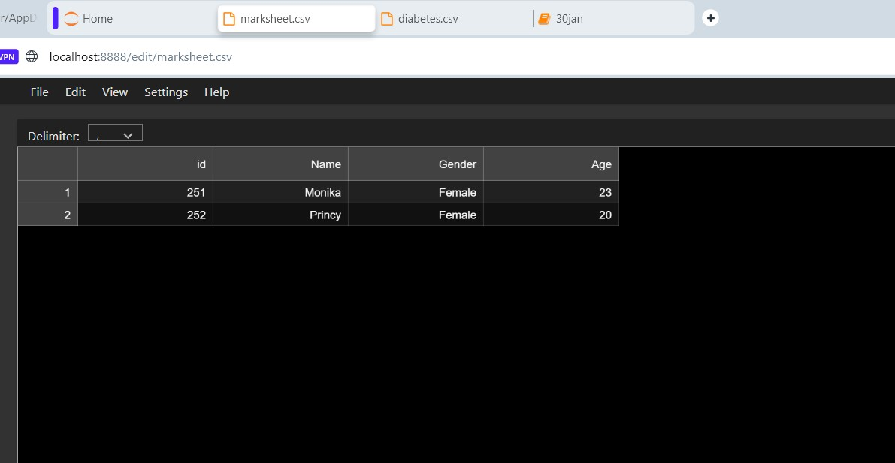

2)Write CSV file using writelines () function

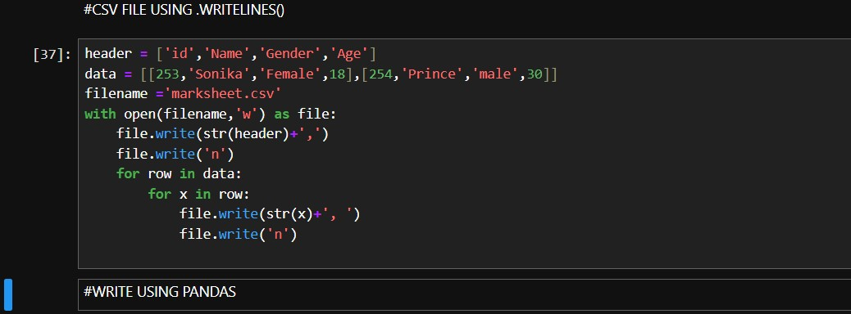

OUTPUT

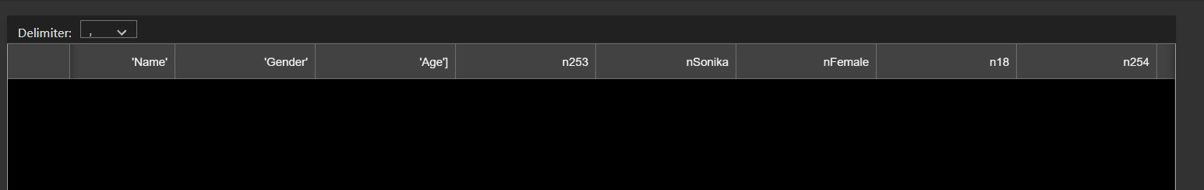

3) Write CSV file using Pandas

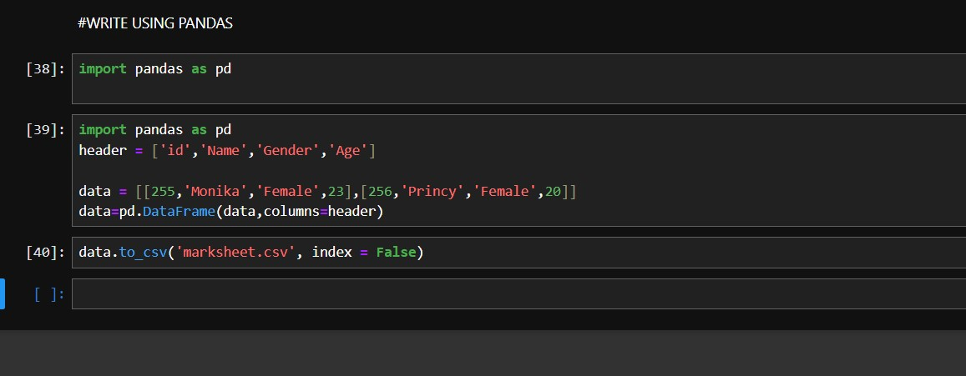

OUTPUT

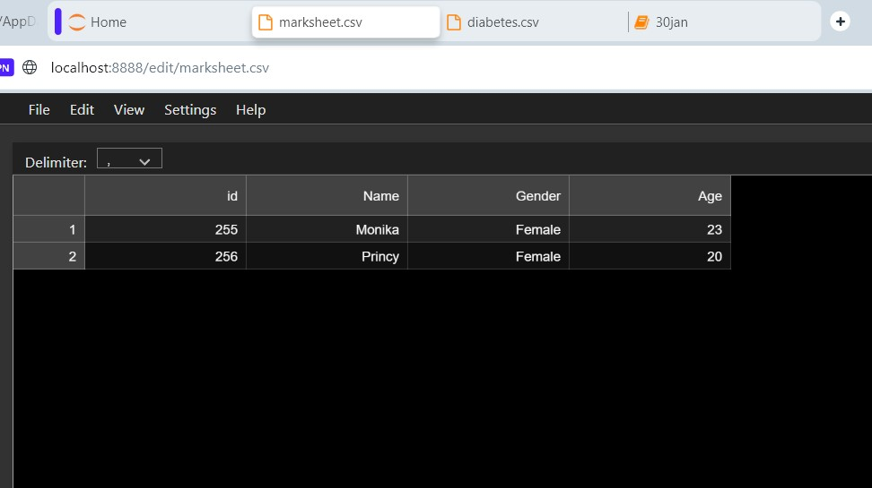

Python Lambda Function

**Python Lambda Functions** are anonymous functions means that the function is without a name

* This function can have any number of arguments but only one expression, which is evaluated and returned.
* One is free to use lambda functions wherever function objects are required.
* You need to keep in your knowledge that lambda functions are syntactically restricted to a single expression.
* It has various uses in particular fields of programming, besides other types of expressions in functions*.*

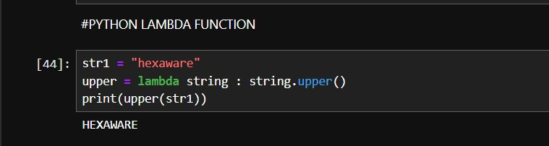

Python lambda function with -

1)**list ()-**Returns a list of Lambda functions, with the version-specific configuration of each. Lambda returns up to 50 functions per call.

2)**filter ()-**The filter () function in Python takes in a function and a list as arguments. This offers an elegant way to filter out all the elements of a sequence “sequence”, for which the function returns True.

3)**map ()** -The map () function in Python takes in a function and a list as an argument. The function is called with a lambda function and a list and a new list is returned which contains all the lambda-modified items returned by that function for each item.

4)**reduce ()-** The reduce () function in Python takes in a function and a list as an argument. The function is called with a lambda function and an iterable and a new reduced result is returned. This performs a repetitive operation over the pairs of the iterable. The reduce () function belongs to the ***functools***module.

